ASSIGNMENT-1
AP25110010841

1] linear Search:
#include<stdio.h>
int main(){
int n;
printf("enter the number of elements:");
scanf("%d",&n);
int arr[n];
printf("enter the elements of array:");
for(int i=0;i<n;i++){
scanf("%d",&arr[i]);
}
printf("enter the key element:");
int key;
scanf("%d",&key);
for(int i=0;i<n;i++){
if(key==arr[i]){
printf("element found at index %d",i);
}
}
return 0;} 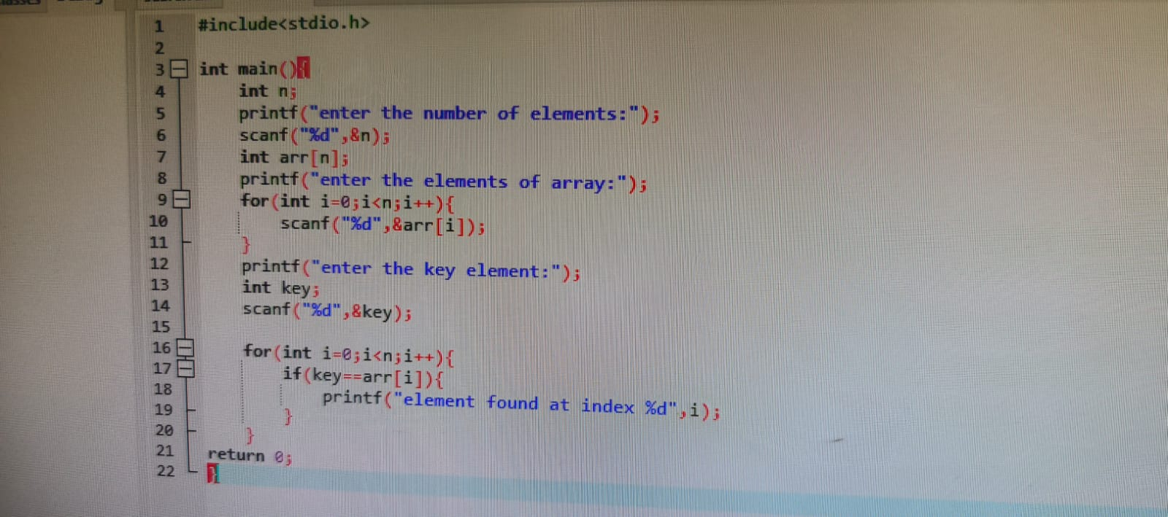

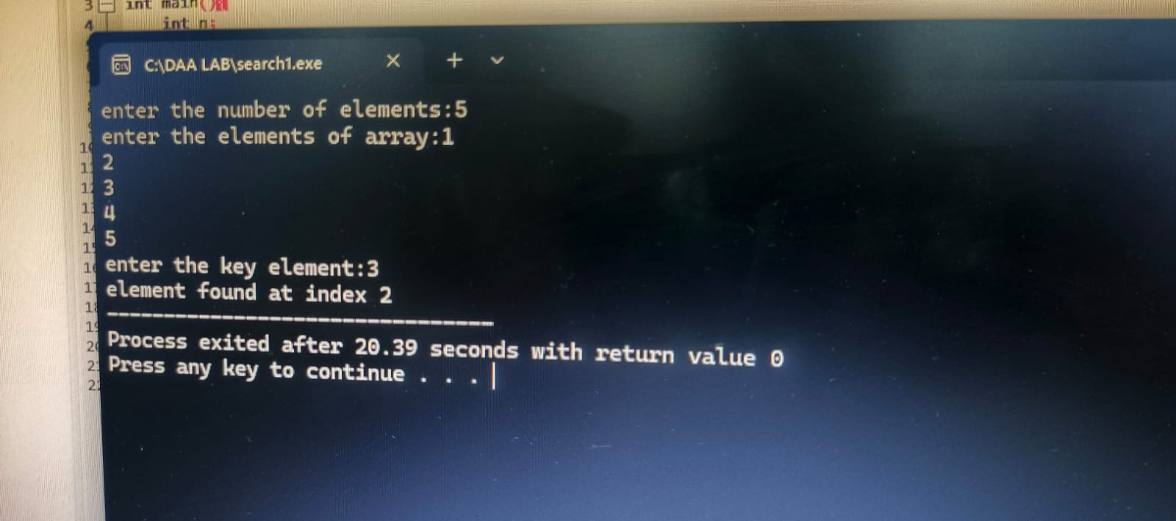

2] Binary Search:
#include<stdio.h>
int main(){
int n;
printf("enter the no of elements:");
scanf("%d",&n);
int arr[n];
printf("enter the array elements:");
for(int i=0;i<n;i++){
scanf("%d",&arr[i]);
}
int key;
printf("enter the key element:");
scanf("%d",&key);

int beg=0;
int end=n-1;
int mid=0;
while(beg<=end){
mid=(beg+end)/2;
if(arr[mid]==key){
printf("found at %d",mid);
break;
}
else if(key<arr[mid]){
end=mid-1;
}
else{
beg=mid+1;
}
}
}